Text 1: (Reading Assignment VWO)
Leonardo Da Vinci
Many people believe that Leonardo Da Vinci, an Italian artist and inventor who lived from 1452 to 1519, was the most brilliant person ever born. He was certainly a man ahead of his time! Records show that Da Vinci loved earth and was curious about everything on it.
To learn about the human body he dissected corpses to find out what was inside. In the 15th and 16th centuries dissecting bodies was against the laws of the Catholic Church; Da Vinci was a brave man!
He was also an inventor; Da Vinci invented a parachute and designed a type of helicopter five centuries before airplanes were invented. Another of Da Vinci’s major talents was painting. You have probably seen a print, or copy, of one of his most famous paintings. It is called the Last Supper and it shows Jesus eating his final meal with his disciples. It took Da Vinci three years to paint the Last Supper which made the man who had hired Da Vinci to do the painting very upset. He went to Da Vinci to ask why it was taking so long. The problem, said Da Vinci, was that in the painting, Jesus has just told his disciples that one of them was going to betray him. He wanted to get each of their expressions exactly right as they all cried out: “Lord, am I the one?”
Another famous painting by Da Vinci is called the Mona Lisa. Have you seen a print of this painting? Or have you been lucky enough to have seen the original? It hangs in a Paris art museum called the Louvre. If so, you know that Mona Lisa has a pensive expression on her face. The painting is based on a real woman, the wife of an Italian merchant. Art historians believe she looks pensive because one of her children had recently died.
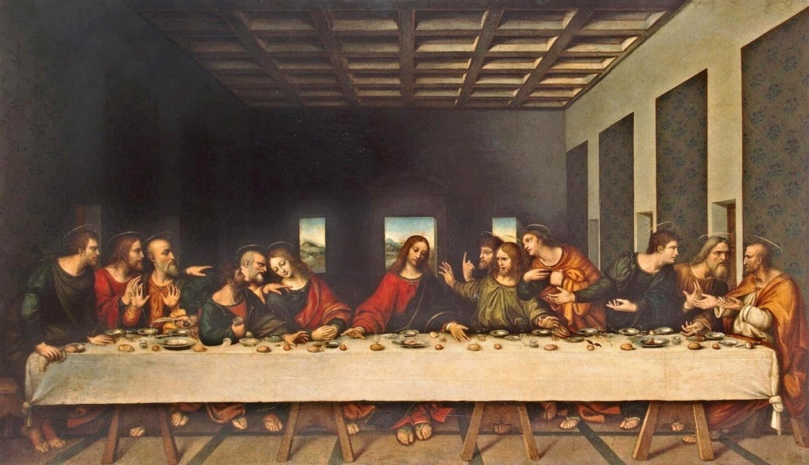
The Last Supper by Leonardo Da Vinci
1. Answer the following questions about Leonardo Da Vinci. (VWO)
- Why does the writer think Da Vinci was brave?
- Why was the man who had hired Da Vinci to paint The Last Supper upset?
- Why do people say Da Vinci was a polymath (Homo Universalis)? Do you agree?
2. What do the underlined words (onderstreepte woorden) mean? (VWO)
- Some people are perplexed when they look at The Last Supper, but others understand it immediately.
- Unhappy
- Puzzled
- Angry
- Because Da Vinci’s work is so famous, many people erroneously assume he has left behind many paintings. In fact, he only left 20 behind.
- Rightly
- Wrongly
- Correctly
- Because his model felt melancholy about the death of her child, Da Vinci had music played to lift her spirits as he painted Mona Lisa.
- Sad
- Angry
- Happy
- Leonardo Da Vinci wasn’t like most other people. He didn’t care what others thought of him and did the things he was interested in. He led an interesting and unconventional life.
- Dull
- Ordinary
- Not ordinary
- Da Vinci’s genius set him apart from people with ordinary minds.
- Mental ability
- Physical ability
- Social skills

Text 2: (Reading Assignment VWO)
Amelia Earhart
On July 2, 1937, at 8:44 a.m., radiomen on the Coast Guard cutter Itasca, which was a very fast powerboat, received this message: “We are on the line of position one-five-seven-three-seven-seven. Will repeat this message on 6,210 kilocycles. Wait. Listening on 6,210. We are running north and south.”
Anchored off Howland Island, the Itasca was waiting to help guide pilot Amelia Earhart and her navigator Fred Noonan to a safe landing. This was the longest, most difficult task of Earhart’s around-the-world flight, and nearly the last. She had taken off from Lae, New Guinea, with a 2,556- mile journey to Howland Island ahead of her. Her plane, a Lockheed Electra, was noisy and shaky. Traveling for six weeks (including stops), it had carried Earhart and Noonan for 22,000 miles. The radio communication above was the last ever received from the aviators. Earhart and Noonan vanished without a trace.
Amelia (nicknamed Meely) and her sister Muriel (nicknamed Pidge) spent many of their growing-up years with their grandparents, Judge Otis and his wife, also named Amelia. Their father, Edwin Earhart, worked as a claims agent for the railroads and travelled a lot, taking the girls’ mother, Amy, with him. The Earhart sisters had happy childhood years and enjoyed a freedom that was unusual for girls at that time. They were encouraged to be physically active and adventurous.
As a young woman, Amelia enrolled as a premedical student at Columbia University. While visiting her parents in Los Angeles in 1920, she took her first ride in an airplane. She was instantly hooked on flying, and began her first lessons, working as a social worker to support her ambitions.
In 1928, Earhart was the first woman to cross the Atlantic Ocean by plane. On that flight she was a passenger. But in 1932, she flew on her own across the Atlantic. And in 1935, she soloed from Honolulu, Hawaii, to Oakland, California, and later, from Mexico City to Newark, New Jersey. She broke speed records and set an altitude record in an autogiro (early helicopter). She was a skilled aviator, and her mysterious disappearance left many questions unanswered. Was she, as some have wondered, spying for the U.S. and captured by the Japanese as World War II heated up? Or did she simply miss the small island, run out of gas, and drop into the Pacific? The curious are still trying to solve this mystery, but Amelia Earhart’s astounding flying records are history. They will never be lost or forgotten.

- Fill in the blanks to complete the crossword puzzle. (VWO)

DOWN
1. At one time Amelia enrolled in pre-med studies at _____ University.
3. Some people think Amelia Earhart was a spy, captured by the _____.
4. On her round-theworld flight, Fred _____ was Amelia’s navigator.
6. Amelia and her sister spent years of their childhood with their _____.
7. _____ Island was Earhart and Noonan’s destination when they were lost.
8. Most people think Amelia’s plane ditched in the _____ Ocean.
11. For her round-the-world flight, Earhart was flying a _____ Lockheed.
12. Noonan and Earhart had already flown 22,000 _____ when they took off for Howland.
13. They took off from Lae, _____ Guinea (a Pacific island).
15. Amelia Earhart was born in Atchison, _____, in 1897.

ACROSS
- The Earhart sisters enjoyed more _____ than most girls at the time.
5. An _____ was an early airplane something like a helicopter.
9. When Noonan and Earhart disappeared, they had almost no _____.
10. Amelia Earhart flew solo (alone) across the _____ Ocean in 1932.
12. _____ was Amelia’s childhood nickname; her sister’s was Pidge.
14. In 1937, Amelia Earhart’s goal was to fly around the _____.
16. The Itasca was a very fast Coast Guard powerboat called a _____.
17. In 1928, Earhart was the first woman _____ to fly across the Atlantic.
18. Amelia was a _____ worker because she liked it and needed money to fly.
19. Radiomen on a boat named _____ received the last message from Amelia Earhart.

